Team One

DevOps | LYIT

Education Interview

Team Assignment

**Education Interview**

DevOps – Team Assignment

**Lecture**

Ruth Lennon

**Team Members**

Aswathy Akhilesh – L00149517

Roshni Kalasyam Umesh – L00130494

Matthew Bergin – L00095247

Conor Dorrian – L00101441

Liam Whorriskey – L00113360

Table of Contents

Introduction Overview 4

Research 4

Technical description of the project 4

Software Development Life Cycle (SDLC) 5

Phases of Scrum Model 5

Scrums & Team Meetings 6

Development Tools Used 9

GitHub - Version Control (Team) 9

Slack 9

JIRA (Team) 10

Java (Liam) 10

Javadoc 11

JUnit Testing 11

Selenium Testing (Team) 12

Bug Testing 12

Security 12

Xampp 13

Visual Studio Code 13

Website Design and Pages 14

Application Considerations 15

Team Member Out Sick 15

Conclusions 16

Aswathy Akhilesh – L00149517 16

Roshni Kalasyam Umesh – L00130494 18

Matthew Bergin – L00095247 19

Conor Dorrian – L00101441 20

Liam Whorriskey – L00113360 21

Website Page Images 22

Frontend Pages 22

Admin Area Pages 25

Table of Figures

Figure 1 – Scrum Meeting – Planning 6

Figure 2 – User Flow Planning 7

Figure 3 – Course Application Planning 7

Figure 4 - Layout Planning 8

Figure 5 – Retrospective and Team Meeting 8

Figure 6 - Adding GitHub to Slack 9

Figure 7 – JIRA how to capture 10

Figure 8 - Java Connection 10

Figure 9 - Javadoc 11

Figure 10 - Database Connection Test 12

Figure 11 – Database Tables 13

Figure 12 - Visual Studio Code 13

Figure 13 – Source Control – Git 14

Figure 14 - PhpMyAdmin Database 15

Figure 15 - Home Page 22

Figure 16 - Login Page 22

Figure 17 - Register 23

Figure 18 - Profile 23

Figure 19 - Course 24

Figure 20 - Application 24

Figure 21 – Dashboard Pie Chart 25

Figure 22 - Dashboard Quick lists 25

Figure 23 – Couse List 26

Figure 24 – Applicant List 26

Figure 25 – Schedule Interview 27

Figure 26 – Interview List 27

Figure 27 - Interview Detail – Accept or Decline 28

# Introduction Overview

This project has been developed by Team 1 for Assignment in DevOps at Letterkenny Institute of Technology.

**Client Quote**

“Our interview process is time-consuming and erratic. We would like to formalise the whole process from end to end by making the system electronic from applying for a course to being notified of the outcome of the interview.”

The system requires the end-user to create an account enable the Apply button. The end-user has a profile page where they can update their personal information. All personal information must be completed before Applying. Admin will receive all applications and allocate an interview date and time.

Development was complete over several weeks and included 4 Sprints with Scrum meetings taking place in class and in the main Library to review completed and targeted daily tasks. As a team, we researched the product requirements and logged and tracked changes with the JIRA and GitHub.

Java connection has been requested by the client and this is used to list users from the database.

This document will provide an overview of considerations and implementations with the client requirements always at the forefront of the requirements process.

# Research

The research was conducted on application design, testing, database development and web application. The choice of Bootstrap HTML was made to deliver the web application as it is responsive and PHP to connect to the database. XAMPP chose to develop the application as it a free open source server solution. For the Java connection, NetBeans was used to create the connection.

# Technical description of the project

The web application will be released onto a cloud server on link192.net. The web application consists of a MySQL database that was created on PhpMyAdmin using Apache Server on XAMPP.

PHP is used to populate and manage the user profiles and courses from MySQL and the database contains Four tables: Users, Courses, Applications and Interviews.

# Software Development Life Cycle (SDLC)

Agile was the approach used to complete the project. This allowed team members to work to their strengths within each Sprint and was managed with JIRA. Within an Agile team, there is no team lead assigned and all team members contribute equally. While deciding on the requirements for the application each team member choose one area each to manage in the frontend (user) and backend (admin) of the project. Sprint 1 focused on the Layout of the project on the front end.

## Phases of Scrum Model

* **Step 1. Product Backlog Creation**

Consists of the product backlog, the features that should be included in the product during the development. This is created by user stories. Every user story (task) should include the following;

* + As a
  + I want to
  + So that I can
* **Step 2. Sprint Planning and Sprint Backlog Creation**

Firstly the team determined what the duration of the sprint should be, allowing the team to work thoroughly. Typically this would be a minimum of 2 weeks. The product owner should determine the importance of each user story while the scrum team should order them within each sprint.

* **Step 3. Working on the Sprint. Scrum Meetings**

To track each task in the sprint, JIRA was used and each task was moved to in Progress and then complete with the time and noted recorded in each task. Each day a scrum meeting was held to define what each team member had completed and what they would be working on next. This allowed each member an equal voice and highlighted any problems.

* **Step 4. Testing and Product Demonstration**

The ideal result of each scrum is a working product. Product testing should be carried out and bugs recorded and any outstanding tasks should be carried to the next scrum and completed first within it.

* **Step 5. Retrospective and Next Sprint Planning**

The product result from the previous sprint should be discussed within a team review and improvement opportunities should be recorded for the next phase. When this is complete the team should start to plan the next sprint.

* **Conclusion / Review**

The main features of the scrum are agility and continuous progress, achieved by continual communication with the stakeholders of the product. Sprint planning should include the product owner to ensure the correct tasks are added to the sprint. During scrum meetings, the team should discuss ways of solving problems and issues. All information gathered through these discussions should be used to improve the next sprint.

## Scrums & Team Meetings

In our first scrum meeting we talked over the requirements and started to create the user stories required for the interview process. We created several diagrams using the whiteboard and all team members participated (see figure 1).

The diagrams were then created using photoshop to give a clear visual of the user flow and the relation they had to each other as outlined in Figure 2.

At another scrum meeting the application diagrams inclusive of admin relationship were created and as outlined in Figure 3.

We completed a daily scrum where we updated each other with what we had completed and what we were working on for that day. This allowed team members with problems to get help and was great way of learning and staying up to date with what was happening within the project.

Each week we had a team meeting in the library and as the project came closer to ending we were meeting daily to go over the release of the product (see figure 5).

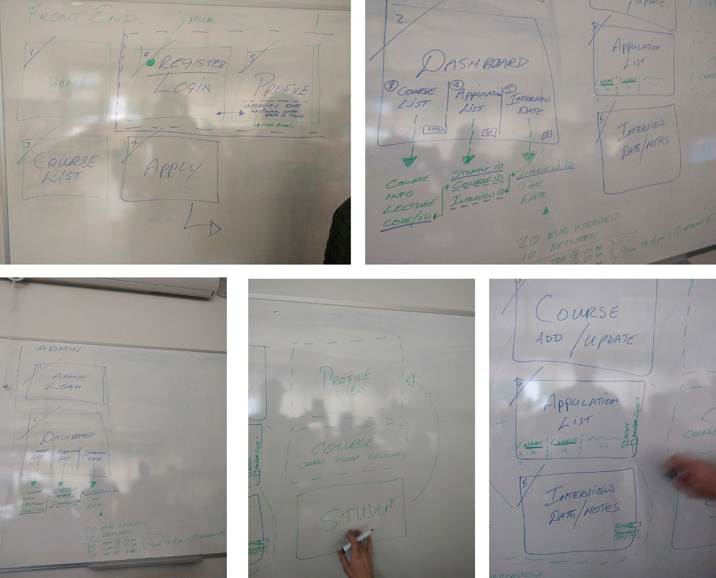

Figure 1 – Scrum Meeting – Planning

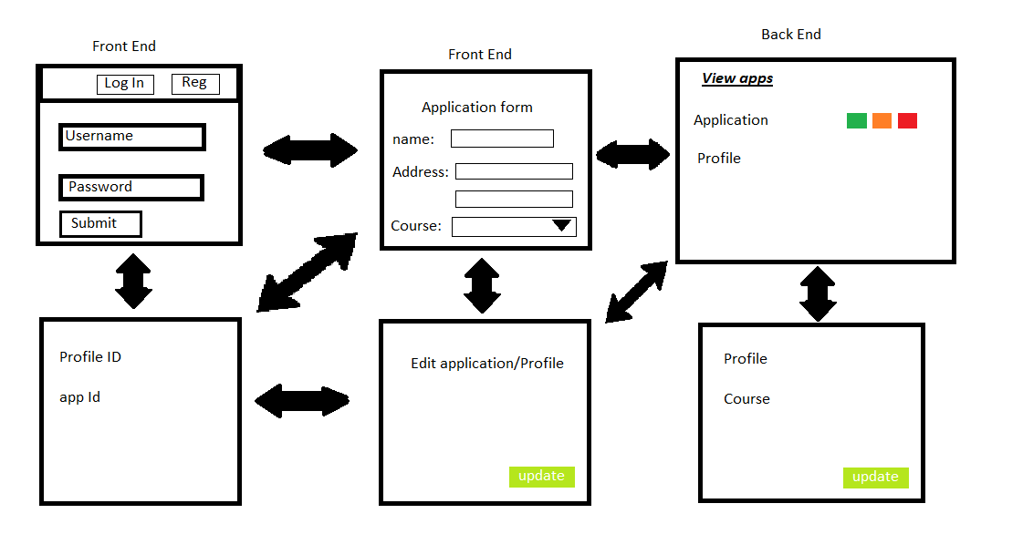

Figure 2 – User Flow Planning

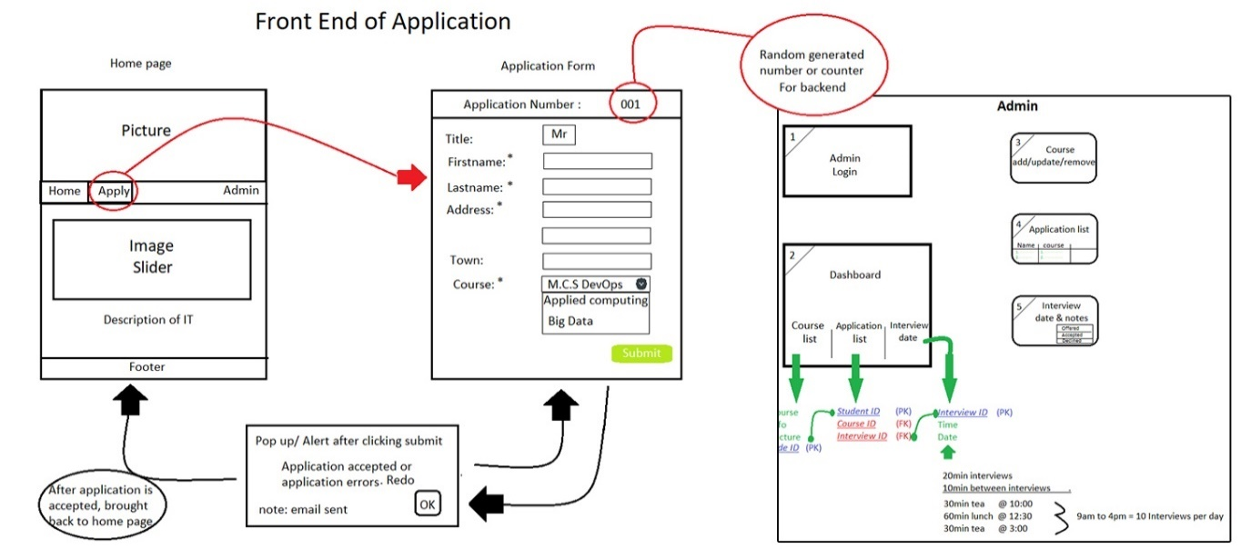

Figure 3 – Course Application Planning

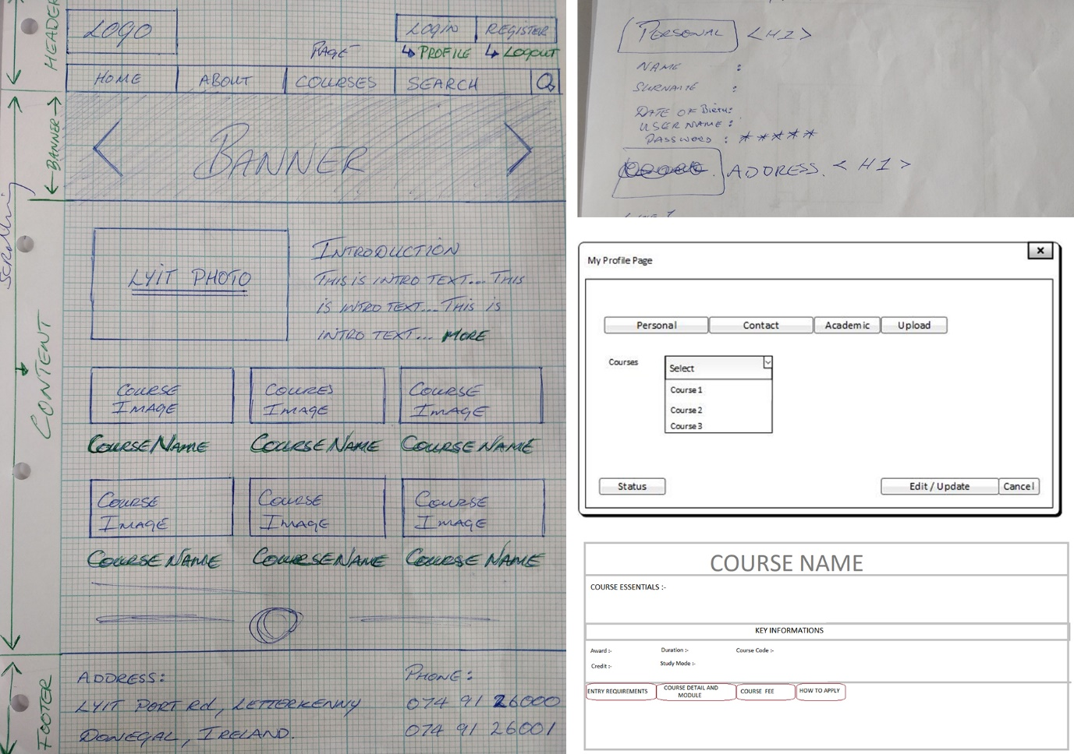

Figure 4 - Layout Planning

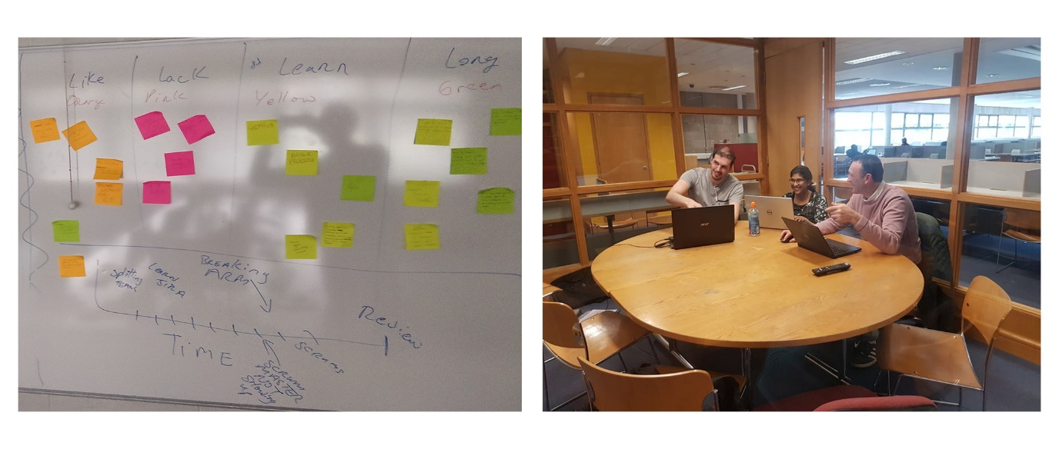

Figure 5 – Retrospective and Team Meeting

# Development Tools Used

## GitHub - Version Control (Team)

GitHub is the tool used for our development collaboration. GitHub version control system enabled the team to keep track of changes and to see the incremental progress of the codebase. The branch feature enabled the team to work away on their own code without faring conflicts between each other. The pull feature allows the local codebase to be updated with any upstream changes so that commits can be made without conflicts. The fork feature allowed individual changes to the codebase which would not affect the main branch, for example, experimental features that cannot be committed on to the main branch.

GitHub version control system also enabled the team to rollback unwanted changes to the codebase. Overall GitHub is the integral part of our development environment which helped the team in collaboration and knowledge sharing, which in turn enabled us in the successful completion of our team assignment.

This was also easy to integrate with VS Code and Git Bash terminal for better submission control.

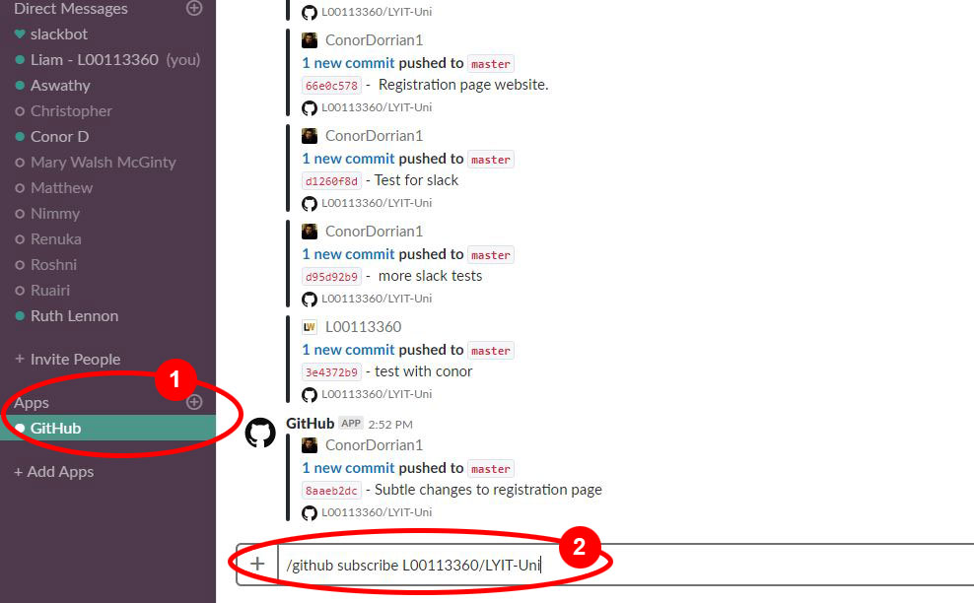

Figure 6 - Adding GitHub to Slack

## Slack

Slack is a cloud-based set of proprietary team collaboration tools and services and was used as the team collaboration tool. GitHub Was added as an app to slack to alert team members of updates and better code management.

The team managed conversations relating to the project and were able to share notes and files as well as arrange a meeting or have a private discussion.

Slack also offers the ability to integrate over 1,500 apps, within this project we used GitHub but as a team, we can see how this would be useful in the workplace.

## JIRA (Team)

Jira is an issue tracking software used with agile management to allow teams to track issues and bugs during the planning and development of a project. Our team used Jira to list all the issues that needed to be completed during the development lifecycle. We created a sprint at the beginning of each week and assigned several issues to be completed during that sprint.

To calculate how well the project is progressing, each issue is given story points which determine how much effort the task is to complete. When a task is completed the story points for that task are entered into a burndown chart which allows our team to see how the sprint has gone and whether it was a success or failure. This can then be used to plan our next sprint and assign an appropriate number of issues that we think can be completed before the end of the sprint.

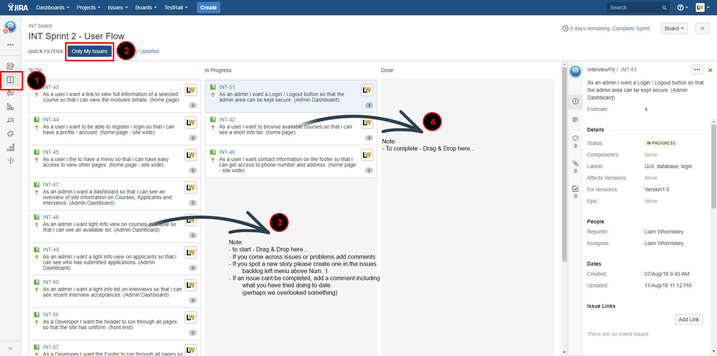

Figure 7 – JIRA how to capture

## Java (Liam)

Java was used to get a list of admin users and will be exported as JSON. This was completed using NetBeans rather than eclipse as we wanted to gain the experience of new software. One unexpected problem was that the server time prevented the java from running. This was corrected by adding the following to the connection string.

?useTimezone=true&serverTimezone=UTC

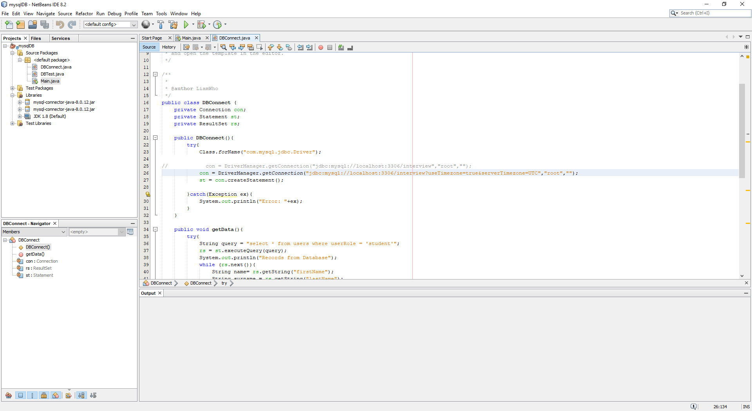

Figure 8 - Java Connection

## Javadoc

A Javadoc was created using NetBeans >> Run >> Generate Javadoc which returned the Javadoc files.

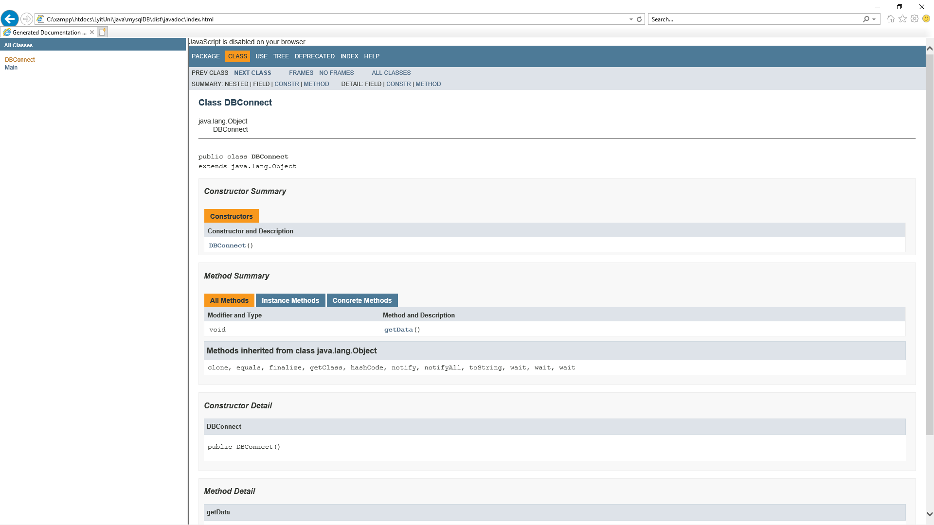

Figure 9 - Javadoc

## JUnit Testing

As a team we decided that we needed to test our database connection. We wanted just a small test. Conor said he would do it as Conor wanted to learn about testing and testing a database connection. Conor had no real experience in testing. Conor created a simple unit test first by adding 2 numbers together and having an assertEquals to 40, this will pass if numbers equal 40 and will fail if it does not equal 40.

After this test Conor went on to testing the database connection. Examples of code in the try catch are as follows:

“Class.forName("com.mysql.jdbc.Driver");” -- Which loads jdbc driver into memory and is used later as a reference .

“Connection conn = null;” -- sets the connection reference to null, otherwise we get an error that conn might not have been initialized.

I also used a catch for using an exception when there is no connection so that we can be told if there is no connection.

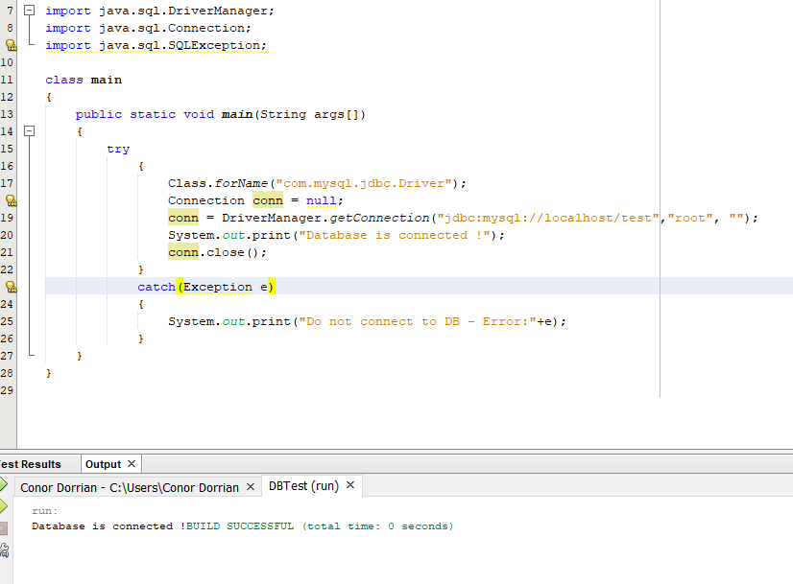

Figure 10 - Database Connection Test

## Selenium Testing (Team)

Selenium is a testing framework used to test web applications. Selenium is very easy to learn and use as it records keystrokes and mouse movement which can be played back instead of having to learn a scripting language like other testing frameworks.

We used Selenium to test the front-end and admin of the website and created a test that would check that the login was working and all the links and buttons on the web pages were also working. These tests were created with a browser plugin called Selenium IDE.

* Frontend area selenium testing was completed by Roshni and is included in the testing folder.
* Admin area selenium testing was completed by Matthew and is included in the testing folder.

## Bug Testing

Login was upgraded to MD5

Min char requirement (8) and must include a number.

## Security

* **Sessions**

Areas of the project are protected with _SESSION control in that if a “userRole” is “student” they will access only the Frontend of the site.

* **MD5 Encryption**

Login will be secured with md5 encryption and will require a min of 8 chars containing at least 1 upper char and 1 number.

## Xampp

* Apache server is used as our server environment.
* MySQL is used as our database.
* PhpMyAdmin is used to manage the database.

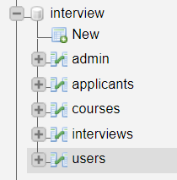

Figure 11 – Database Tables

## Visual Studio Code

VS Code was used by all team members to complete the project. This software was new to most team members. It was used as it has a built in Terminal and we could track changes directly with GitHub.

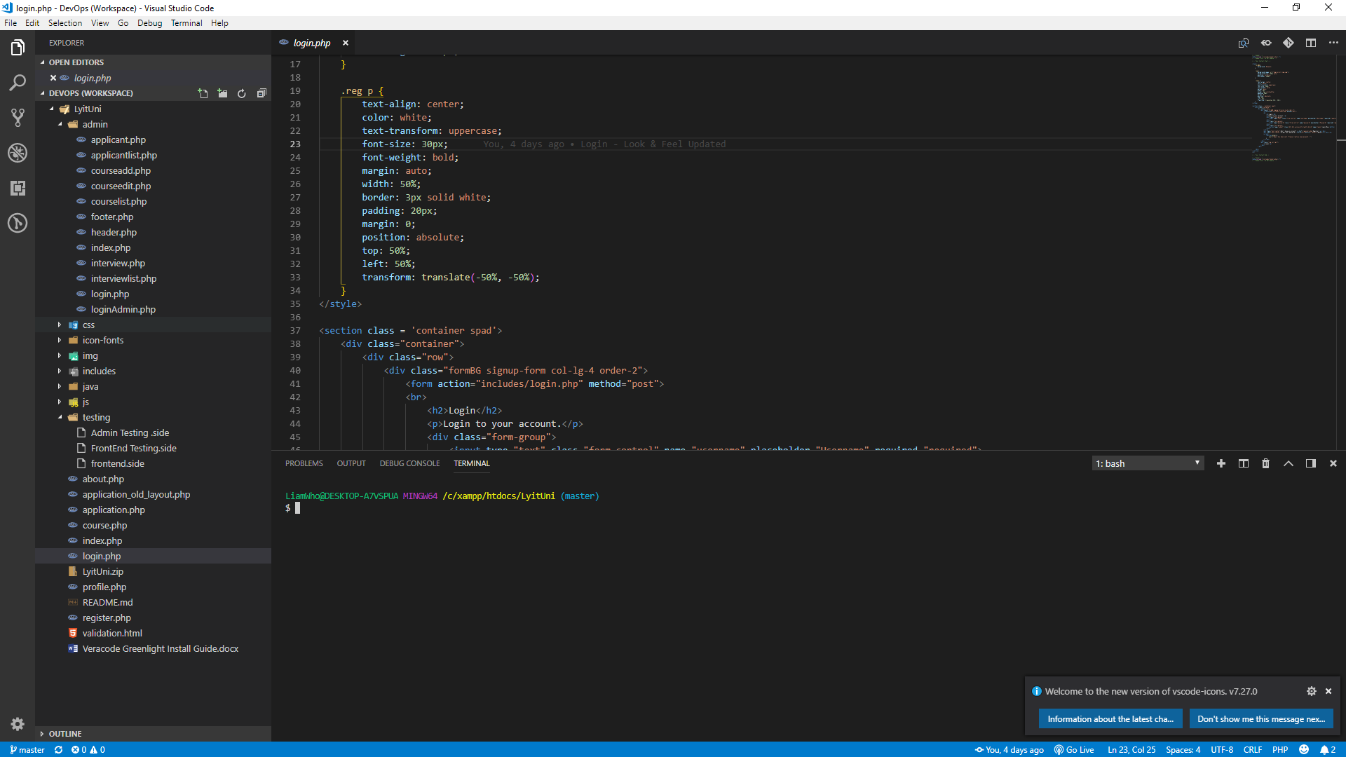

Figure 12 - Visual Studio Code

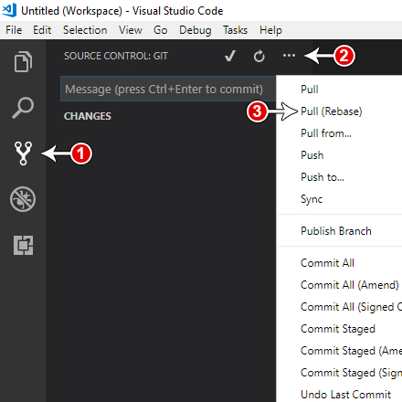

Figure 13 – Source Control – Git

# Website Design and Pages

The website application was created using Bootstrap and PHP. PhpMyAdmin was used to create and manage the database (see Figure 14). Each team member then created a page as outlined below. This was decided on after a number of planning meetings.

Sprint 1 seen the completion of the layout for the frontend (see Figure 4) and the admin area was also started. Admin was completed for the end of Sprint 2 and we had a progress review with the product owner. The product owner was happy with the Look and feel of the site but did point out a few changes and correct us on some of the information we were displaying on the site. This was corrected in Sprint 3 and the function was added to the site ready for Product Release.

All screenshots are listed at the end of the document for each page.

**Front End Page creation**

* Home page / Header and Footer (Liam)
* Registration and Login (Conor)
* Profile (Roshni)
* Courses (Aswathy)
* Application (Matthew)

**Admin Area**

* Login (Conor)
* Dashboard (Liam)
* Courses (Aswathy)
* Applicants (Aswathy & Matthew)
* Interview (Roshni)

The database was created by Conor and added to by each team member as we progressed through the project.

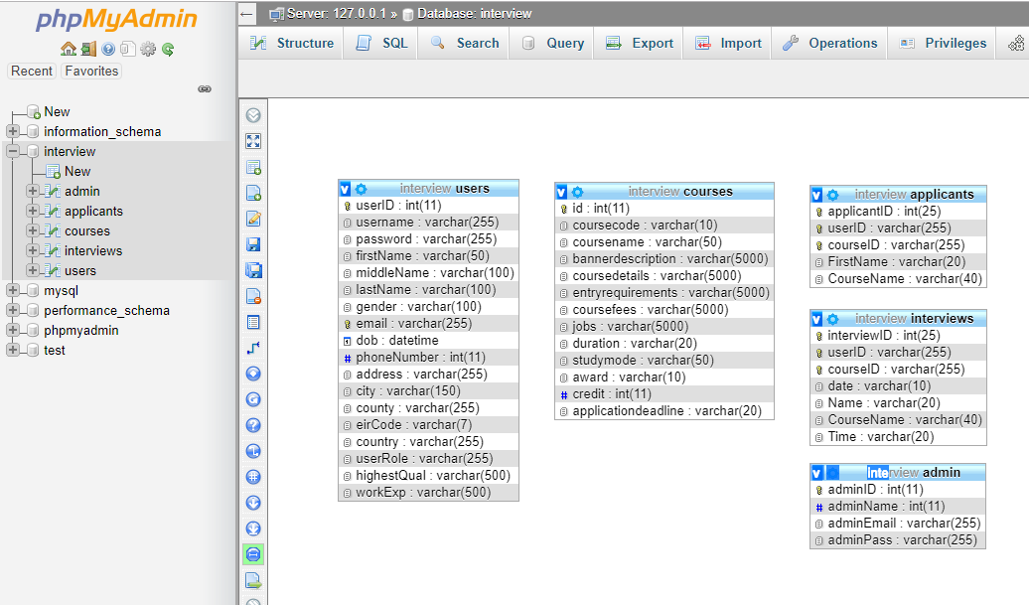

Figure 14 - PhpMyAdmin Database

# Application Considerations

The team considered using a number of applications inclusive of MongoDB, Tomcat Server, Docker, eclipse. In the end the team choose not to use these products as we had to lot to do in learning PHP and MySQL as well as learning to manage JIRA and GitHub for version control and task management.

# Team Member Out Sick

Liam went out sick for a week in the task and was replaced with Ruairi as cover. The team give Ruairi and overview of the project to date and gained from his experience in the way of security for the site.

Once Liam returned to the team he was updated with what tasks were completed while he was off sick.

# Conclusions

## Aswathy Akhilesh – L00149517

As part of the team assignment, I was part of the team assigned to create a portal for scheduling interviews for prospective students to their respective courses.

We followed an agile approach for the execution of this team project. A member of the team was made the scrum master, this was cycled among the team so that each of the team members was given scrum master duties at least once. When I was assuming Scrum Master responsibilities, I organized and coordinated stand up meetings as well as providing the team with positive feedback. As part of the agile process, we first created a basic backlog after deciding on the pages and basic user flow. JIRA was the tool used for maintaining the backlog of tasks as well as logging time to completed work.

The pages were then assigned to the team for commencing development. The pages that were assigned to me were:

1. Course Detail Page
2. Admin Course List Page
3. Admin Course Add Page
4. Admin Course Edit Page

Course detail page was planned in a way such that it could be used as a template for any type of course. While working on the Admin Course List page, I had to decide on how to go about the page render. After researching and testing with multiple plugins I decided on Datatable.js as the most suitable plugin for rendering data as a list. This further helped the team out as I was able to help with the implementation of this plugin in several other pages that had similar requirements.

During the period when Liam was out sick, I worked on a POC for integration of MySql database. As part of this, I had a Java rest API service as the backend to our PHP frontend. The entire solution was also dockerized. This solution was presented to the team, the team appreciated the effort and were happy with the result however the learning curve for Java rest API made it extremely hard to add to the current sprint. Due to these factors, this approach was dropped.

Once the team decided on the approach for database integration I started working on my pages.I designed the table structure for my pages. Datatable.js plugin provided tools for getting data from the database and populating the grid view. Add course page was implemented first, using jQuery and MySql connection to save course details to the database. This data was then populated on the Course List page. Edit page was also implemented using the knowledge acquired while working on Add course page, here instead of data being added to the database data was updated. I knowledge gained from working on these pages aided me to help the team in the implementation of pages that had similar functionality. Course detail page was also modified to get details from the database based on the course id selected.

In addition to my tasks, I also implemented functionality on several other pages.

1. Linked index page to course detail page based on the selected course.
2. Implemented the page functionality as well as scheme changes for Admin Applicant List page.
3. Implemented interview schedule functionality which saved interview schedule details to the database.
4. Minor functionality was fixed on several pages in the course of testing the flow of the pages.

Tools used: **IDE : Notepad++,Version Control : Git (GitHub),Agile : Jira,Development : HTML, CSS, jQuery, Php, Datatable.js, nicEdit, MySql**

It was a great experience for me working on the project, I was able to contribute to the project as an individual as well as a team, I was able to help the team using the knowledge gained from the research done while working on my individual tasks, this helped in the overall completion of the project.

## Roshni Kalasyam Umesh – L00130494

Our team was given the task to formalise the whole interview process from user registration, login and apply for a course to being notified of the outcome of the interview. The whole project was a good learning curve for me because I have learned more about agile software methodology especially Scrum, I have gained more understanding on the advanced web page development and functionalities, learned more about the importance of team collaboration and communication.

At the beginning of Project, I have collected the requirements and studied the process which has helped me to start on this project with confidence. The details and flow diagrams discussed during team meetings helped me to visualise the whole project. With this confidence, I had approached the Web Development. As the project required to understand PHP and HTML commands, I had invested very good time to learn advanced PHP programming and HTML syntax. This has facilitated to get a very good momentum in the project and helped me to share ideas and suggestions while I discuss with the team members.

JIRA was used to record and track the progress of the project. I found Jira was very helpful because of the user interface, it was easy to log our user stories, backlog grooming and tracking the same. This has given the idea of what all tasks are completed, and which are in progress. JIRA had an important role in the completion of the Project.

GitHub was used as a code repository. A repository was initially created in the GitHub by one of our team members. A master branch was created by default. Also, we created a feature branch so that it can be shared across team members. Pull requests were in local computers.

The pages I had taken was the profile page, interview page and interview details page. Profile page was to keep the user information and update it if necessary after the registration. Interview Page was to show the confirmed applicants for the interview and their details were in the interview details page. I had created the pages using PHP using HTML commands. The database I had used was MySQL. I had created a connection to the database and done all the functionalities.

We also had daily stand up meetings and we rotated the role of Scrum master(Rotating Scrum Master). I also got an opportunity to take the role of Scrum Master. It was a challenging role for me as I had any experience in Scrum before. I tried my level best to clear all the impediments that came our way. One greatest impediment that came in our way was during that time when one of our team members who have a particular skillset went on sick leave and he was replaced by another member who was having a completely different skillset. But I believe that we had managed the situation quite well and we educated him well about our project. I was also doing Selenium testing along with one of my team members. I was assigned to the frontend part of the website. For this work, I had used Selenium IDE plugins for Google Chrome to ensure that the front-end flow is working without any issue.

The most important thing I want to point out was our teamwork and communication. We were great as a team and we had shared knowledge with each other. I have done all effort to coordinate the discussions with every single member. And the members also, they helped me on many occasions with ideas and valuable suggestions.

Overall, the project went very fruitful and showing in the great results. This has given me a great exposure to the Agile Environment and I really enjoyed working in this.

## Matthew Bergin – L00095247

During this project, I was part of a team of 5 that had to create a website that would be used for scheduling course interviews for students. To complete the development of this website we implemented an agile scrum methodology.

The main part of this was to work in timeframes called sprints, which allowed us to organise and keep track of our time. During each sprint, one of our team was given the role of Scrum Master. This would generally be a role that only one person on a scrum team has, but as we all wanted to experience the role of Scrum Master it was given to a different team member each week.

During the week that I was the Scrum Master, I organised the sprint backlog and set team stand up meetings so that we could keep track of all the issues that had been set for completion during the sprint. I also made sure that if any team member had an issue that was stopping them from completing work, that I was there to help them sort out the issue.

The website was developed using mainly HTML and CSS for the front-end UX. The back-end database was created with MySQL and connected to the front-end with PHP.

We were given separate web pages to work on and have completed before we began work on the back-end. I worked on an application form that the students would fill out to apply for a course and also the applicant view page for the admin part of the website.

The applicant view was an overview of each applicant so that the admin could see their application details and offer them an interview. The front-end design for these pages was completed during the first two sprints and then I started working on connecting them to the SQL database with PHP. This was completed in the following two sprints.

To keep all of the code for the website consistent between team members, we used GitHub for continuous integration. I committed my code every week when I had finished working on it and was able to pull the code that the other team members had committed to stay up to date with it.

During the development of this website, one of our team members Liam was out sick and replaced by a new team member for a week. We had to get this new member up to date with our codebase and ensure that he knew how to use the technologies that we were using.

I was tasked with testing the admin part of the website with Selenium to ensure that all links to pages and admin input was working correctly. To do this I used the Selenium IDE plugin for Mozilla Firefox and completed tests by recording my keystrokes and mouse movements to test that each button and link worked. When all of these tests were created they could be run as a group at any time by any of my team members.

Overall, I feel that the development of the website was successful and enjoyed working in an agile scrum environment. The new technologies that I learned were GitHub, Selenium and Jira. During the development of this website I also improved my PHP and HTML skills and have a better grasp on the full-stack development and connecting an SQL database to the front-end of a website.

Working in an agile team also gave me a better understanding of agile and the roles involved such as Scrum Master and Product Owner.

## Conor Dorrian – L00101441

As a group we decided that I would work on login and registration for users at the start of the project. We decided to write all our files in .php instead of html as it was easier for us to connect to the files and to connect to the database. This also cut out confusion for later in the project. In this project we used agile and scrum procedures the whole way through.

I first started on the login page. After I drew up a few sketches I created the login for users. When the first sprint was over we had to show our product owner a visual copy of our website with no real functionality. The product owner spotted a problem with my login page and registration page. Both login and registration page had the same button text “Submit”. This was changed right away as I did not even really think about the text in the submit/login. We just didn’t realize or forgot that users could get confused by this. The Login button text was changed from submit to Login.

In sprint 2 we were a lot better, we planned and organised tasks better and we were more fluid as a team. In the second sprint we had a lot more meetings and we were a lot more talkative to each other. I personally thought we jelled well as a group. In sprint two I had created an admin login and I created the database. Creating the database at first was a challenge as I had not created a sql database in a few years. I learned a lot during this and I am glad I decided to create the database for the project. I learned how to create foreign keys in phpMyAdmin which took me a while to get. I also learned what a primary key, foreign key and normalisation was again. Using scrum and agile in this project really helped me understand it better. In sprint two I was a scrum master for a week. I enjoyed this a lot. I had meetings every morning for 15 mins. I also learnt about sprint reviews and retrospectives.

In sprint three, it was all about backend process. Backend would me biggest weakness and I find it very hard to understand php at times. With the help of Liam, me and him done the admin login backend. He helped me understand what was going on. After this I went on to do some testing on the java files. I wanted to make a connection test, so I created a small test using NetBeans which is also a new technology I am using.

## Liam Whorriskey – L00113360

The team project was to create an interview system that required registration, profile management and course detail. All of this had to be managed in a database and an admin user would issue interview dates for the applicant. Each interview should be 20 minutes with a 10-minute break between interviews.

The project was completed using **Agile** and the team worked very well together. Each team member took on the role of Scrum Master for one week. The role of Scrum Master was beneficial as I got to see how other team members were dealing with the tasks they were assigned via JIRA. We had a daily scrum to understand what each team member had completed and what they were going to work on next. This helped a lot and I can see how this would be good in an employment area as related tasks within a team could be focused on to ensure that the dependencies are completed together and all the team.

**JIRA** was used to manage each sprint and tasks were added to the backlog as user stories. This was useful as I got to see how each team member was progressing through their tasks. I also learned that as we got further into the project new user stories would be created and added to the backlog in preparation for the upcoming Sprint. We were able to view our burndown chart for an overview of how we were progressing.

We used **Slack** as a communications tool and had a team discussion area where we could talk over problems and share ideas. This was very useful as we would arrange meetings and share tutorials with each other. We also learned that we could add a GitHub alert as an addon so Slack became my goto place to stay up to date with everything that was happening. I can see how a tool like this is good practice in any workplace.

**GitHub** was used to manage the version control of the project and allowed me to work on my part of the project in a branch. When a task or page was updated or complete I could merge it with the master branch and would GitHub would highlight if there were any code conflicts allowing for a decision to be made about how to correct the code conflicts. GitHub also works as an app with most industry tools, I added it to slack to alert me of team updates and it is built into VS Code by default.

My role in the team was to build the homepage in the site and separate the header/footer into PHP include files to run throughout the site. I also created the dashboard in the admin area. The site was created using **Bootstrap** to allow it to display well on PC, Laptop, Tablet and Smart Phone.

I used **Visual Studio Code** for the first time as I was told it is widely used in the industry. I really enjoyed working with it and learned that it can support direct input to GitHub as it is built into it. I also learned that it has a terminal built into it also and after completing some online tutorials I used this new to me software to complete my part of the project.

I created the java connect using **NetBeans**, this was also a new to me software. I struggled with this as I had to figure out how to connect it to **XAMPP** and after some research, I learned that I had to use **MySQL-Connector** to communicate with the database in phpMyAdmin. I had a problem with the time setting in and this was fixed by sending the time setting with the connection string. I am still trying to get it to export the returned information to JSON so that I can use it in the website admin area.

I was put on sick leave for 2 weeks and for that duration, I swapped teams with Ruairi. This was a good experience for me as I had to adapt quickly to their project. I also got the benefit of fresh minds to related tasks. This was difficult at the start but it gave me a good feel for what it is like in the workplace when a team member is unwell or out on holiday.

# Website Page Images

## Frontend Pages

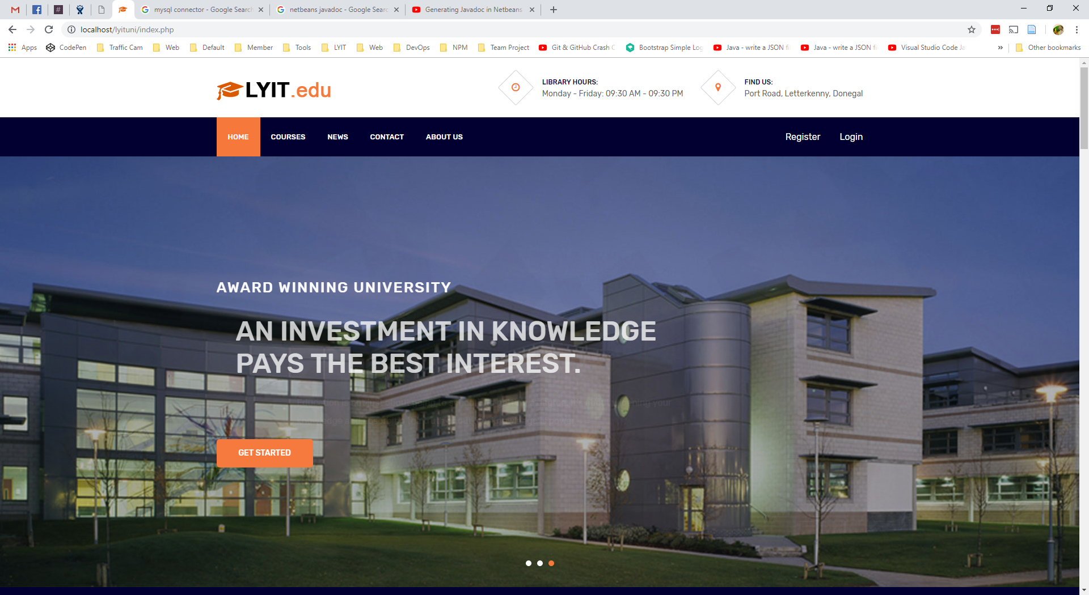

Figure 15 - Home Page

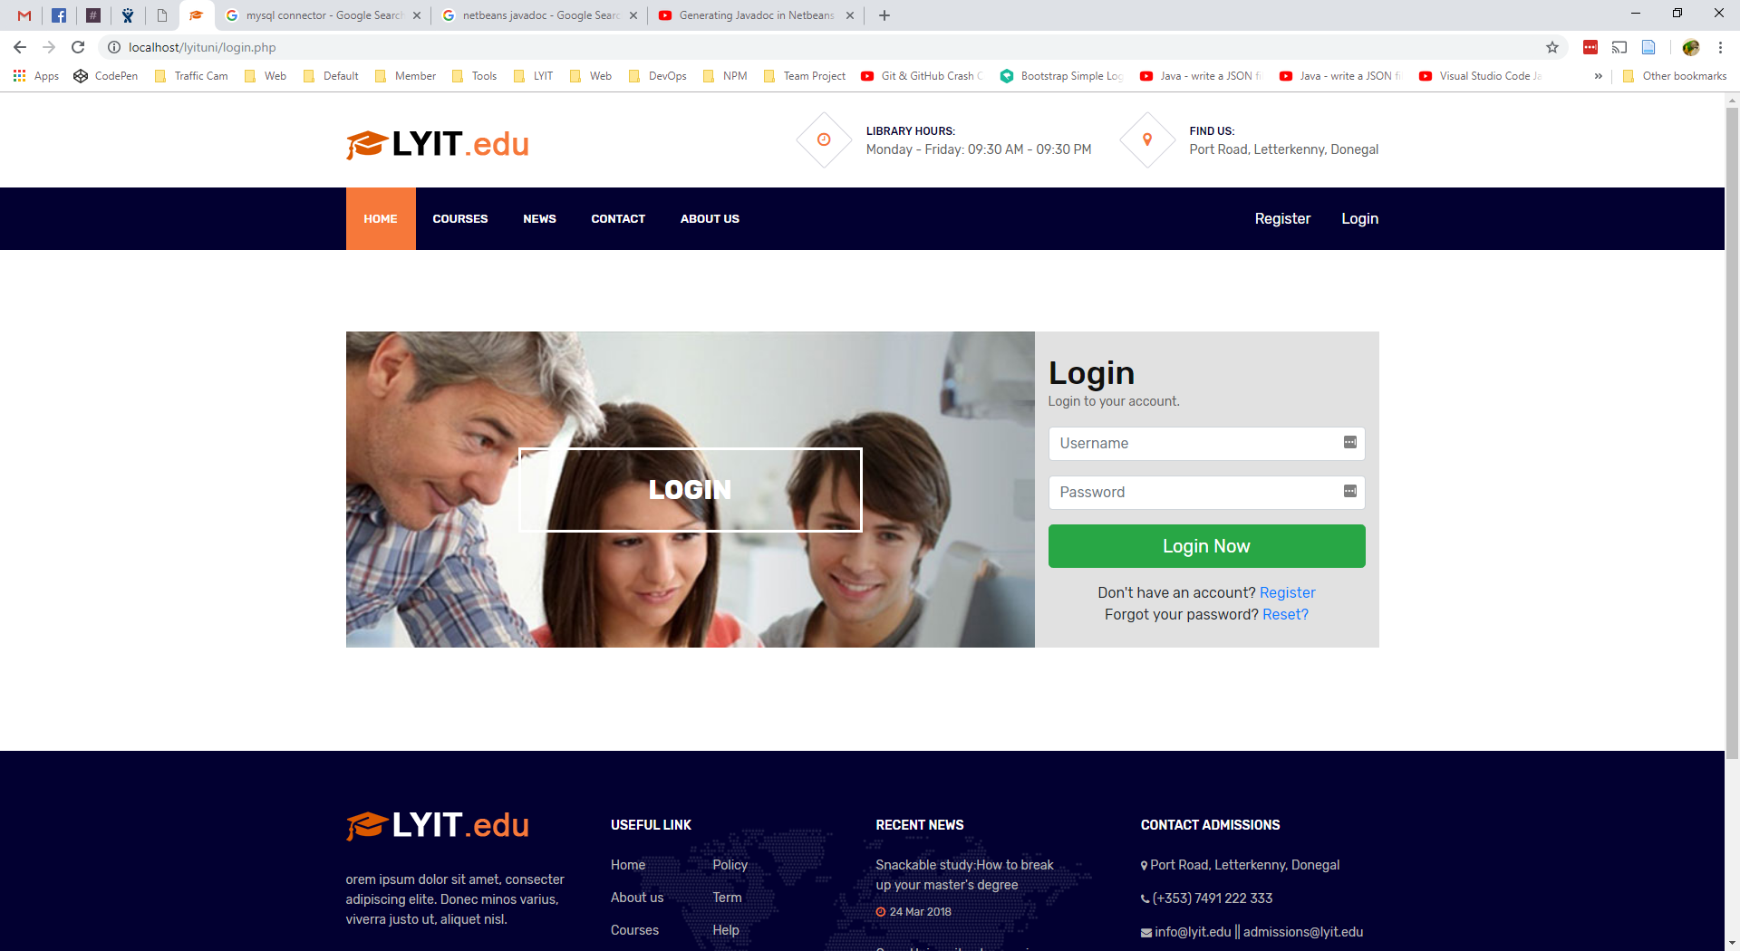

Figure 16 - Login Page

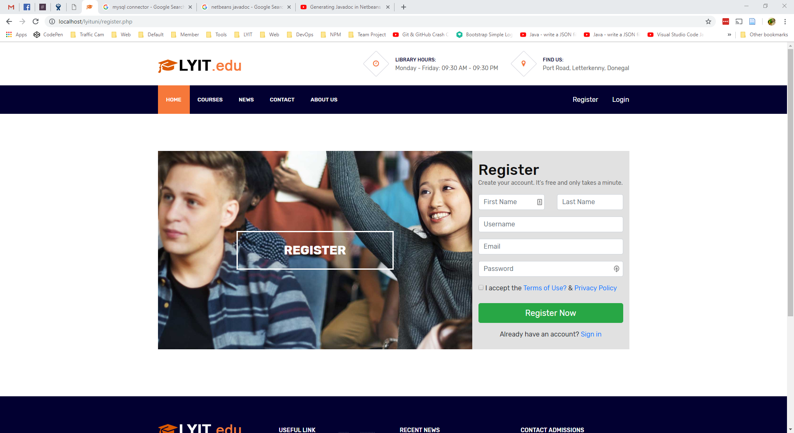

Figure 17 - Register

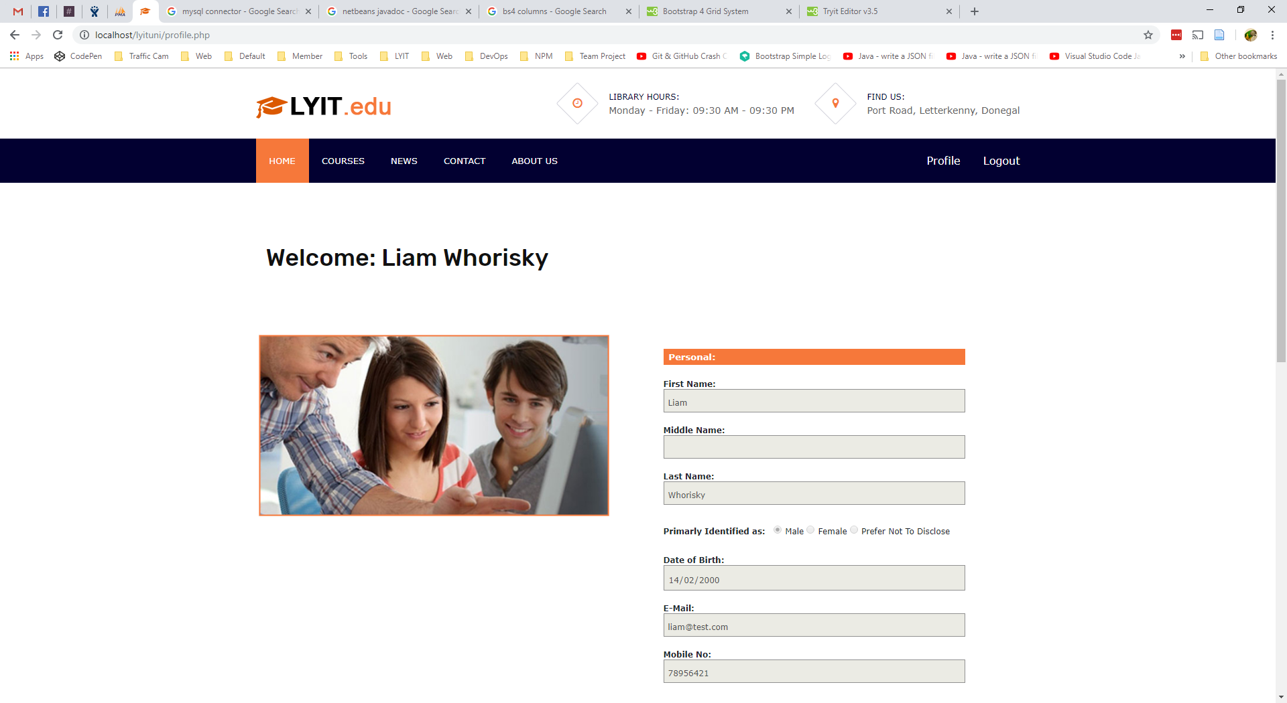

Figure 18 - Profile

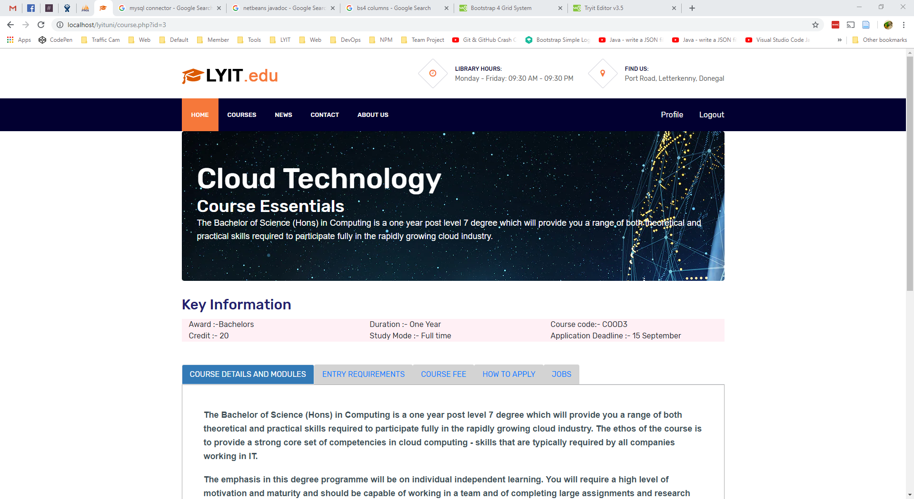

Figure 19 - Course

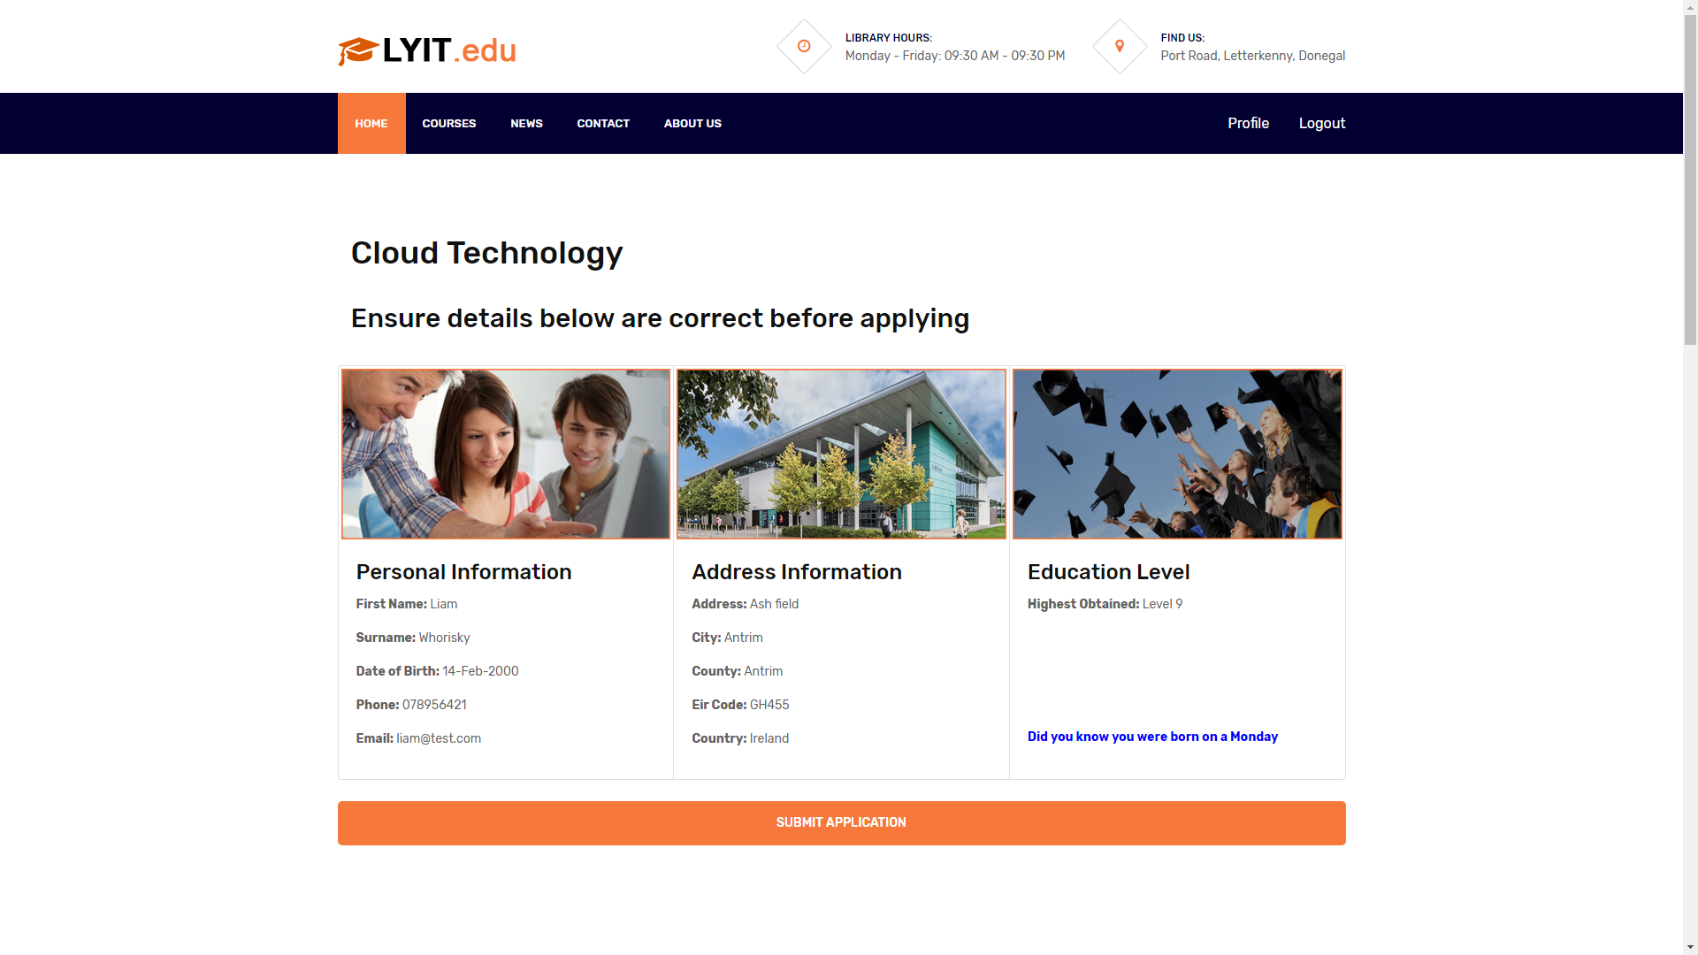

Figure 20 - Application

## Admin Area Pages

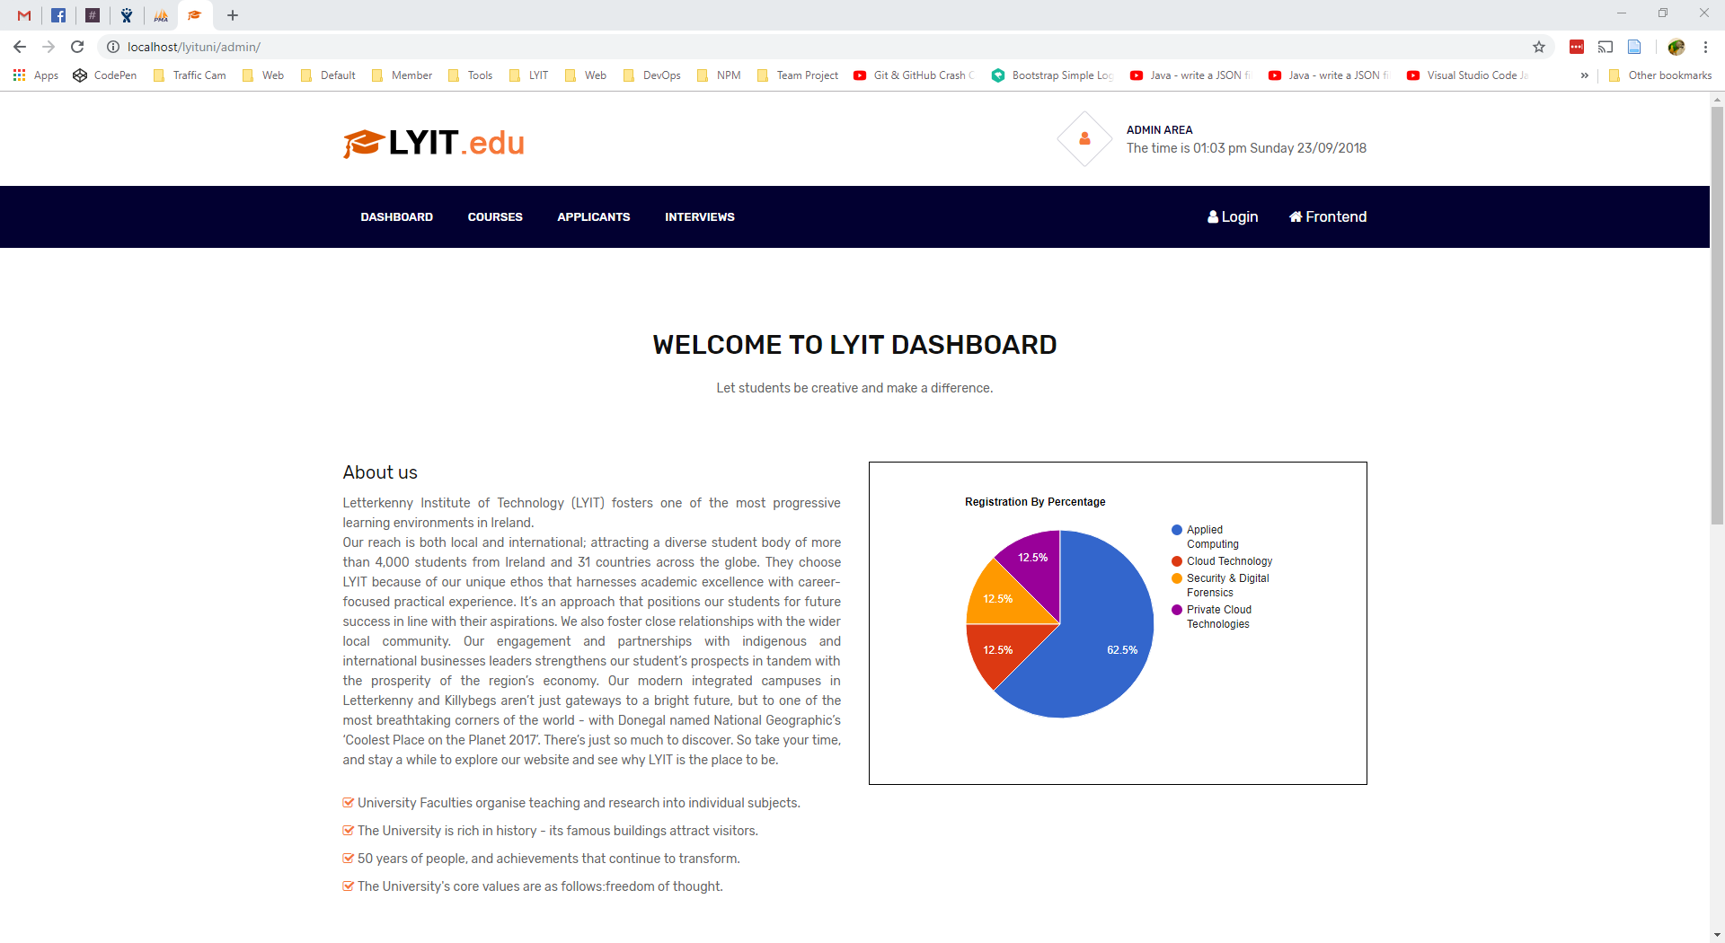

Figure 21 – Dashboard Pie Chart

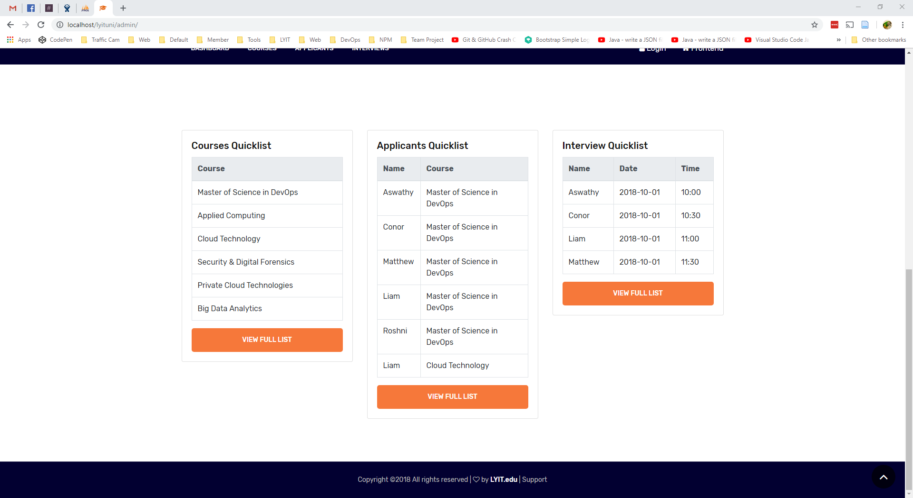

Figure 22 - Dashboard Quick lists

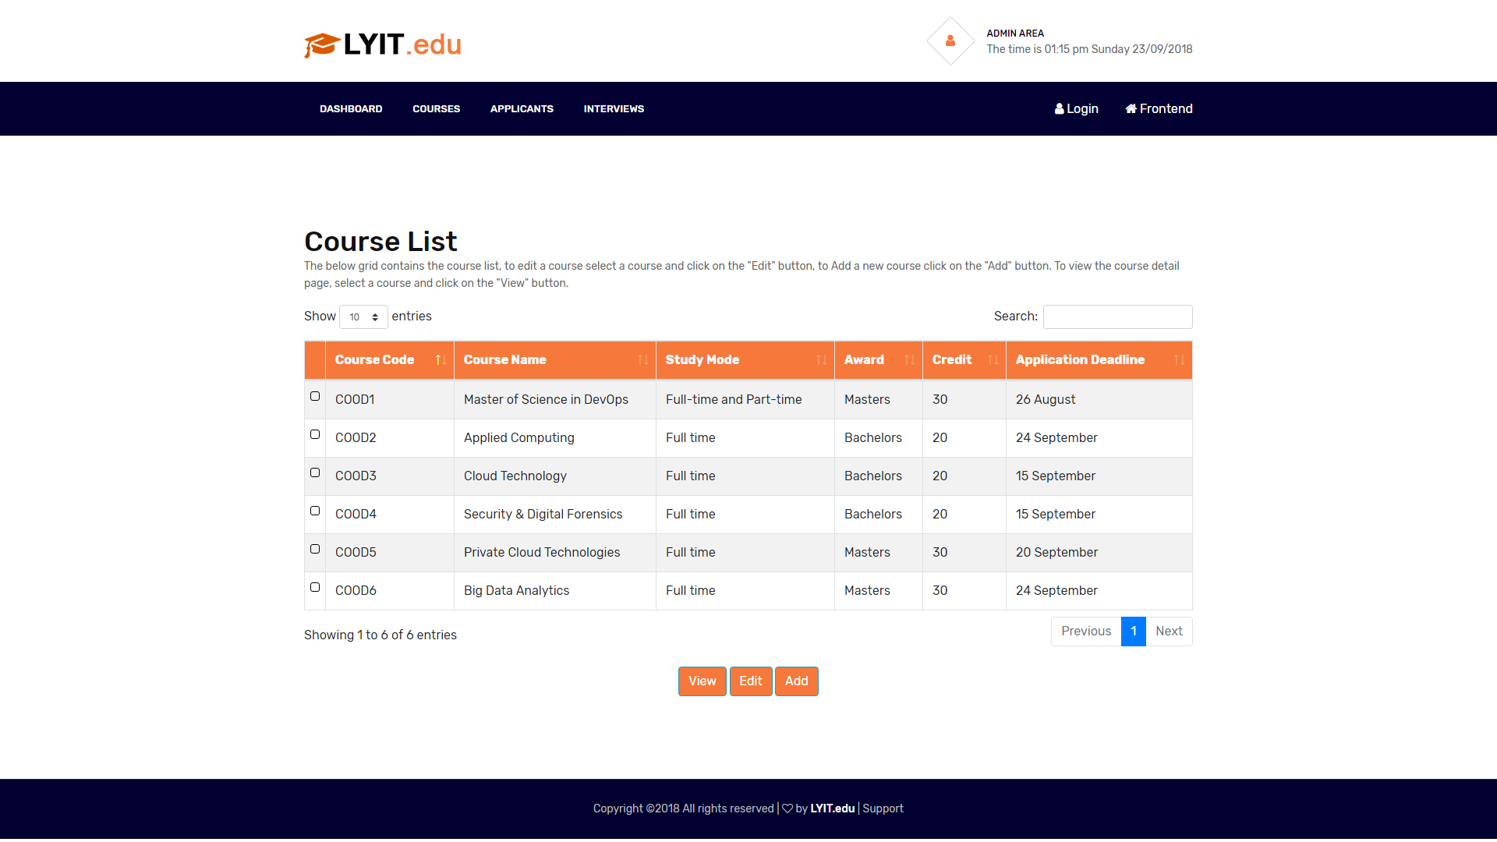

Figure 23 – Couse List

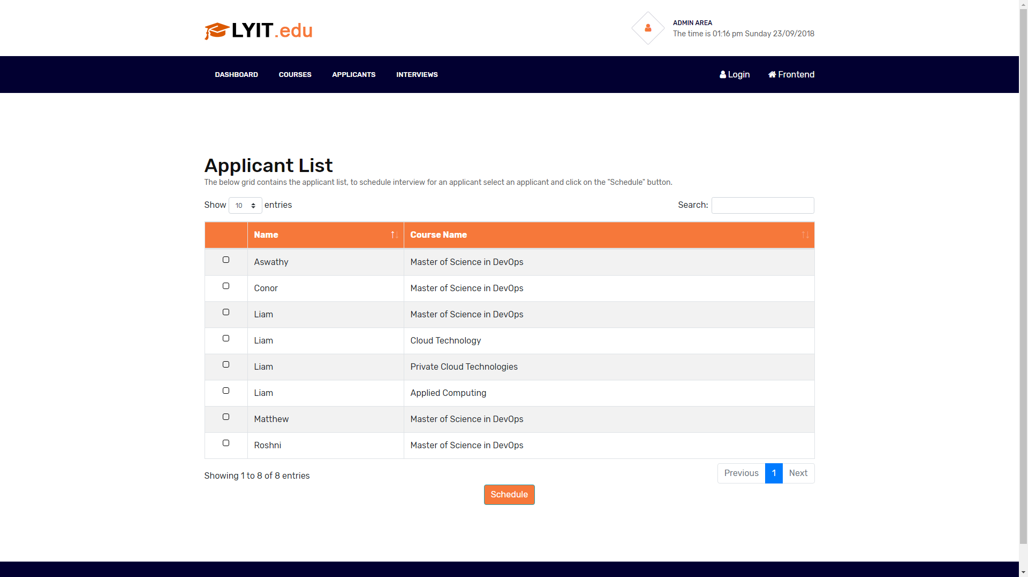

Figure 24 – Applicant List

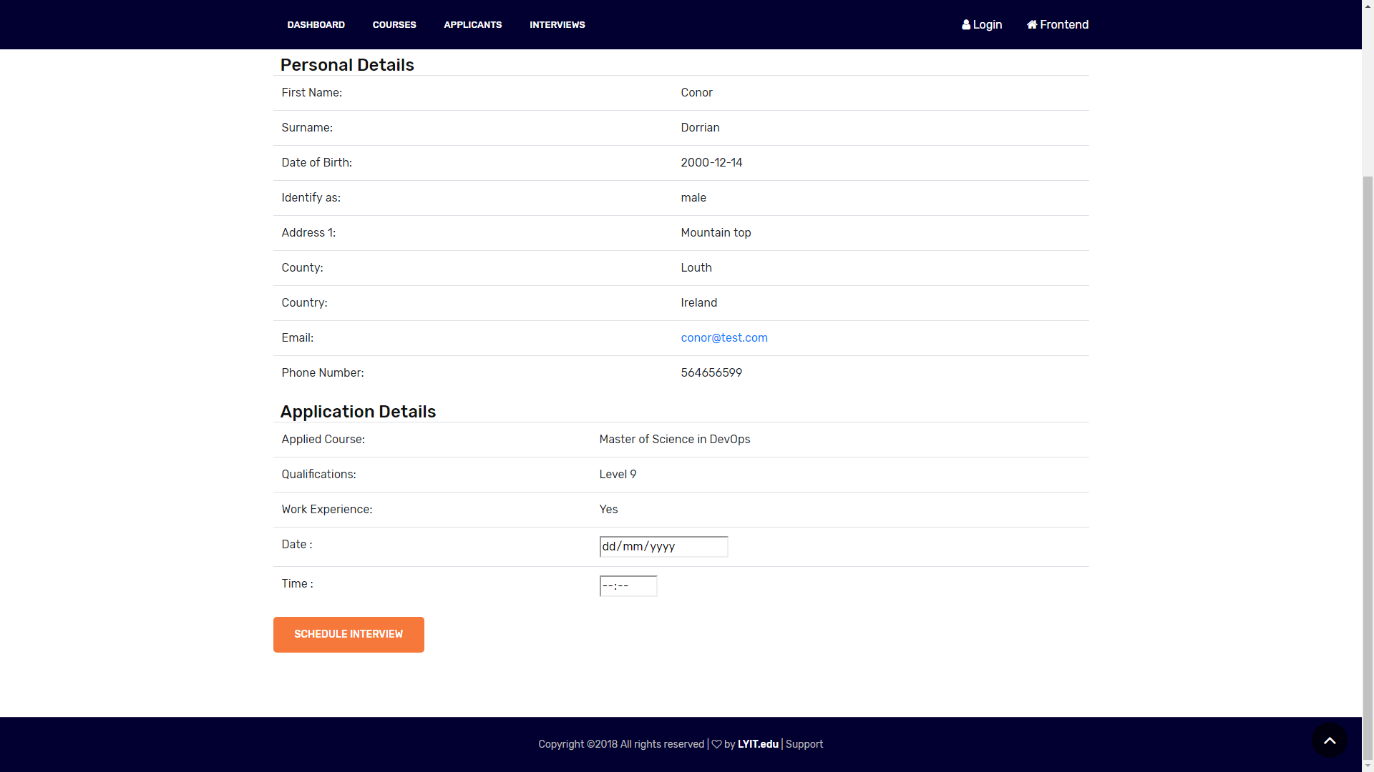

Figure 25 – Schedule Interview

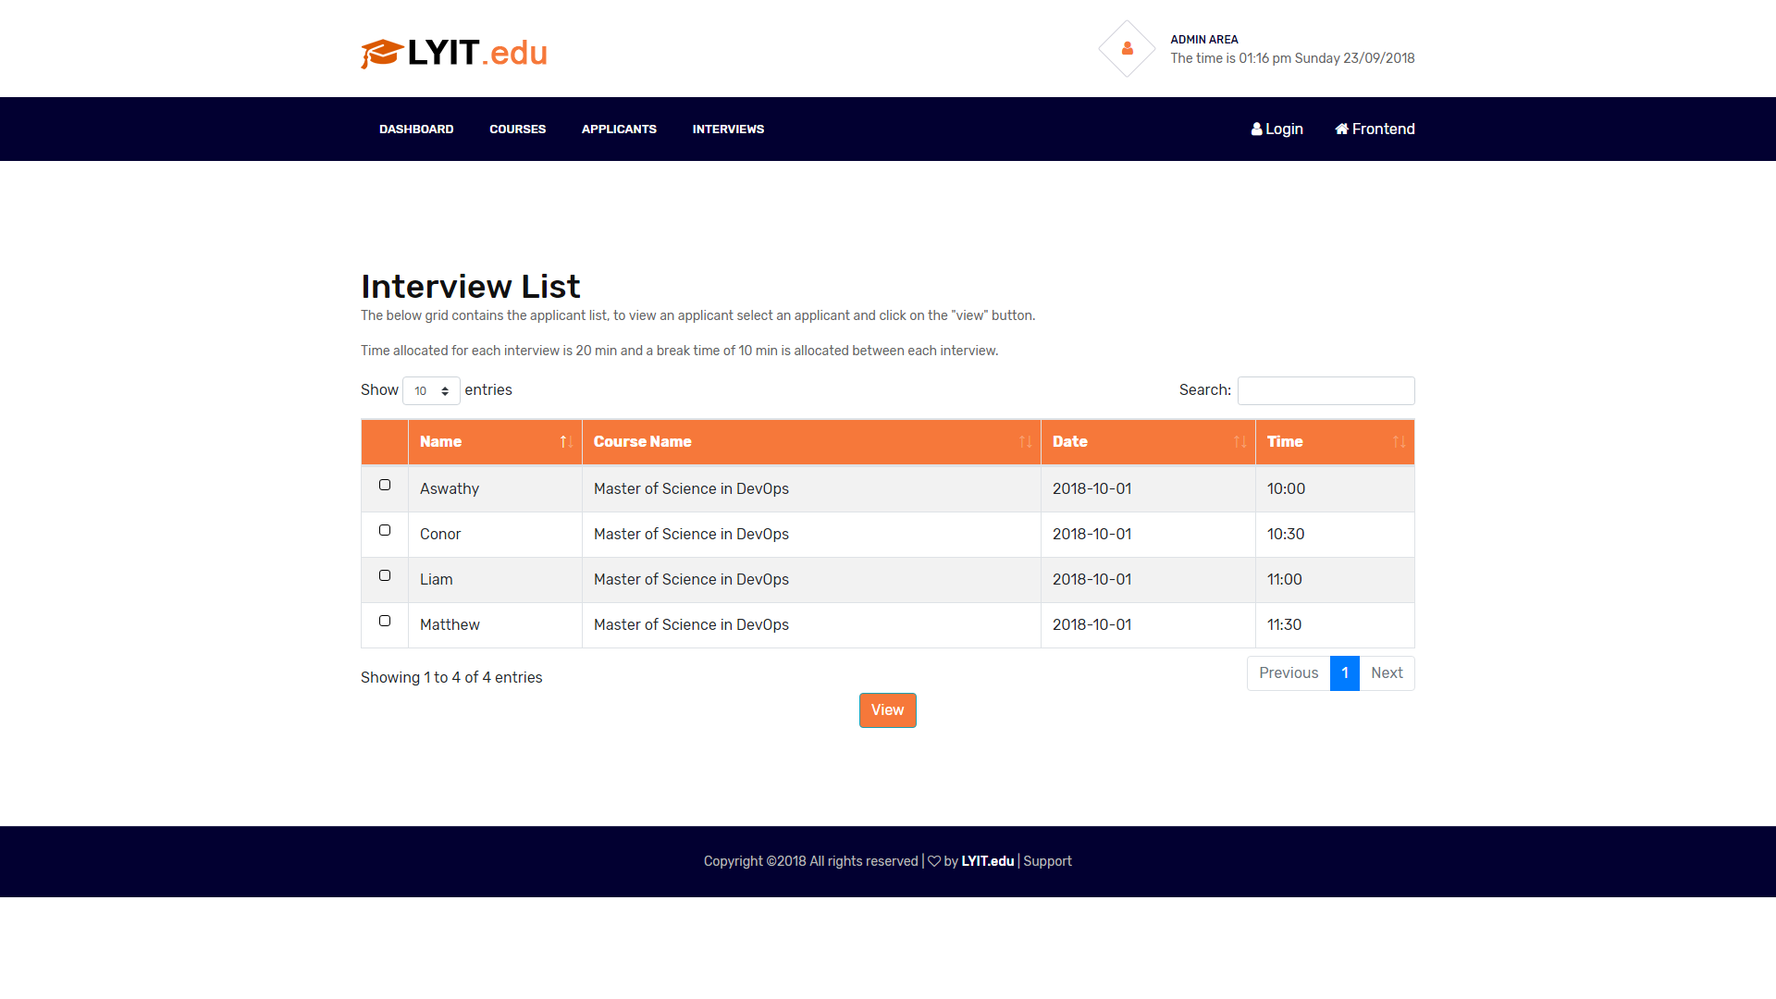

Figure 26 – Interview List

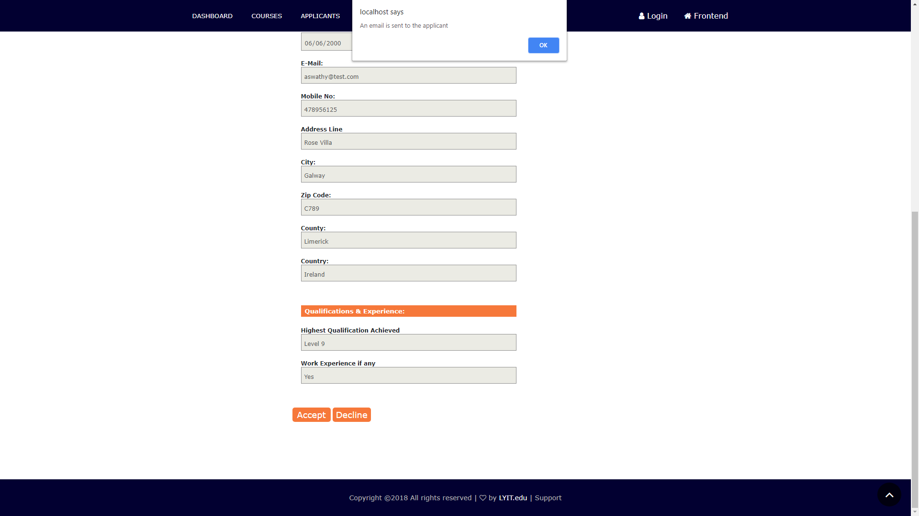

Figure 27 - Interview Detail – Accept or Decline